Lab 2

Convolution & Discrete Fourier Transform

# Objective:

* Learn the concept of Convolution in the space domain.
* Learn the concept of Inverse Fourier Transform.
* Learn the concept of Multiplication in frequency domain.

# Example: Inverse Fourier Transform

In this example, we show the transformation for an image from frequency domain to spatial domain using inverse Fourier Transform.

* Create a zeros matrix of size 21x21, then change the following pixels to be ones:
  + Pixels (9,10) and (11,10)
* Get the inverse Fourier transform of the image using ***ifft2***.
* The result of ***ifft2*** contains complex and very small values that must be pre-processed before displaying.
* This is done by getting the ***abs*** of the image***.***
* Display each of the above images and its inverse.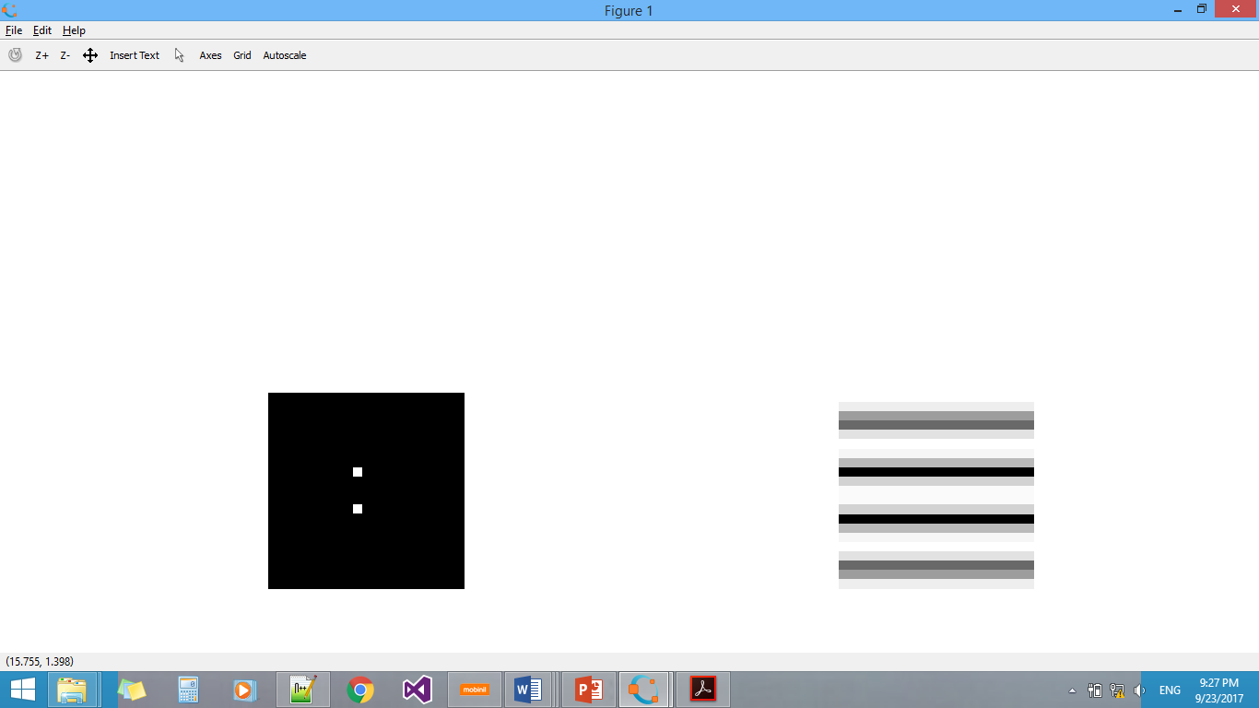
* What image gives an inverse Fourier transformation to be something like this?

# Example: Multiplication in frequency domain

In this exercise, we transfer the image and the filter to the frequency domain, hence we can perform a multiplication operation, then we inverse transfer the result.

* Read any image from your choice then convert it to gray level.
* Calculate the Fourier transform for it using ***fft2***, then shift it using ***fftshift***
* Generate the filter .
* Calculate the Fourier transform of the filter using ***fft( filter , rows(image), columns(image))***.
* Perform a multiplication operation between the image and the filter in frequency domain using np.multiply***.***
* Display the result use the ***abs***  then  ***log ( image +1 )*** before plotting the image.
* Then you apply inverse fourier transformation using ***ifft2.***
* To display the result use the ***abs*** then before the before plotting the image.

# Experiment 1: Convolution in space domain (30minutes )

In this exercise we experiment convolution in space domain for 2d images and linear filters.

* Read any image from your choice then convert it to gray level.
* Generate another version of the image after adding salt and paper noise with density=0.05.
* Convolve in space domain using the function ***convolve2d*** the following filters with the images and write your comments about the results:
  + On the image after adding noise.
  + On the image without noise.
  + On the image without noise.
  + On the image without noise.
* After applying each filter display

1. gray scaled original image
2. image after adding noise to it
3. The four images after applying the four filters

Images in **one single figure** using ***show_images*** function.

* What are the uses of these filters?

The first one to smooth the img but decrease noise

Second one to detect the edges and show the detail of photo

Third one do same of second but to detect vertical edge

last one do same of third but to detect horizontal edge

* How can we modify the filter to make the output more descriptive?
* For edge detecting filter we may increase the values of positive and negative numbers

For noise and smooth we may increase the size of filter or use Gaussian filter smooth while preserving edges

Useful New Functions and Attributes

|  |  |  |
| --- | --- | --- |
| Name | Attribute or Function | Usage |
| np.log | Function | to get log for matrix (element-wise) |
| np.abs | Function | to get absolute value for matrix (element-wise) |
| np.multiply | Function | to multiply two matrices (element-wise) |
| np.power | Function | to power a matrix (element-wise) |

For Fourier Transform functions, check: <https://docs.scipy.org/doc/scipy/reference/fftpack.html>